Las Vegas ASG Reversed Applique Design

American Sewing Guild Logo is linked to the ASG national chapter to download. It is copyrighted, please review logo policy. Your user name and password will be required, you can also enter the site through www.asg.org and enter through "members only" area. This design is free to all ASG members.
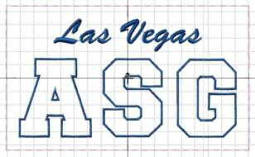
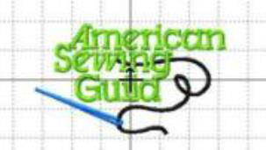

- First you want to hoop a tear away stabilizer along with a polar fleece or material of choice for the underneath applique.

- Using a water soluble stabilizer on the front of the sweatshirt will help keep lettering from sinking into the sweatshirt.

- Aline item to be embroidered (sweat-shirt) over the two items hooped positioning it in the hoop where you want the design to stitch out, this can be temporarily pinned into place. The first color to stitch out will be a basting stitch used to secure sweatshirt to be embroidered to the hooped material.

- Second color to stitch out will be the design and Las Vegas wording.

- After the stitch out is complete, remove the the hoop and sweatshirt from the machine. Remove tearaway and trim the polar fleece close to the design.

- Carefully trim the front of your sweatshirt or embroidered item in the ASG lettering for a reverse applique, this will expose the polar fleece that is on the underneath side. Leave between 1/8 to 1/4 inch of sweatshirt material next to the inside of the stitching. It will roll up, fray and look cool!

- Press as needed....a little puff of steam never hurts!

- American sewing guild has 3 color stops, you can sew in multiple colors or use only one depending on the look you want. The logo design can also be downloaded from www.asg.org national site.

- Note: Las Vegas ASG below is .pes format, you will need to convert the design to your particular sewing machine format..

